Welcome to the Magnificent Phone Record Processing Program!

Thanks to this wonderful piece of software, generating phone reports for Mission President from raw invoices is now easier than ever. Pretty much anything you might want can be accomplished in:

1. Less than 20 minutes of computer working time.

(but this could be bigger if you have a huge mission, or really talkative missionaries)

1. Less than 5 minutes of person working time.

Often it goes even faster than that, if the computer decides to not be slow.

So, in order to make this all work, we need a couple of things:

1. Directory Information.
2. An Invoice.

Obviously, we need an invoice to get the data from. Also, the program requires at least one directory file, which contains information associating names with phone numbers, and defining the mission calling tree- who’s allowed to call whom. You will have to make the directory files every transfer. A directory file is an Excel spreadsheet with rows of the following format:

Phone# Area Name Companion1 Companion2 Calling Code

The program only reads from line 4 down, so as to leave room for human-readable stuff at the top. You’ll see when you look at old Directories.

The companion spots are optional, but if Companion2 is listed, there must be a Companion1 first. If Companion1 is filled, but Companion2 is blank, then Companion1 is the name of the phone. If both are blank, then the Area Name is the name of the phone. If a phone is not being used during a certain transfer, list its Area Name as “Extra”. If a phone is assigned to a closed area, then list Companion1 as “Closed”.

The really great part about the directory, and possibly the confusing part, is the Calling Code column. Calling Codes define a phone’s position in the mission calling tree, and prevent you from having to make a list of everybody that any phone is allowed to call, like you used to have to do under the old system. Calling codes have the following format:

For Zone Leaders: Z - A single number, which is the Zone Number.

For District Leaders: Z.D – the Zone Number and District Number separated by a period.

For Regular Missionaries: Z.D.E/S – Zone and District Numbers, followed by a period and E or S, to

identify this companionship as either Elders or Sisters.

For Senior Couples, Lawyers, Etc.: U – the letter U signifies an untracked phone. The number will be

replaced by its name in other records, but this phone will not have its own record sheet.

Special Tracking: Nr/g/b – the letter N signifies a usually-non-mission phone that President wants to keep

special watch on. The r/g/b bit is optional, and specifies an individual color coding for this phone when it shows up in the records. If it’s left out, or mis-typed, a default “Special Tracking” color will be used instead. The numbers r, g, and b specify the red, green, and blue channels for the color. If you’re familiar with hex codes, you can also use a 6-digit hex value to specify the color: NRRGGBB

For Officeniks/APs/Etc.: T – the letter T signifies a phone which has universal calling privileges but is

still tracked, i.e., has its own report.

Examples:

Zone leader Code: 1

District Leader Code: 1.2

Elder Code: 1.2.E

Sister Code: 1.2.S

Mission President’s Code: U

Your Code: T

Mysterious Stalker People: N200/100/200

You need to make these directory files for every transfer. Remember where you save them!

You’re going to get the invoice in an e-mail. Remember where you save it, too.

We now have everything we need to run a basic phone report. Open the Phone Records program:

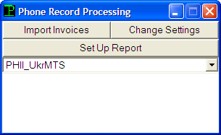The big white space is for the program to give you error messages and stuff. Now, you have 4 options. You can import new invoices, change settings, set up a report, or select an importer. If you have more than one importer available, you can select which one to use with the handy drop-down box. Most likely, though, you only have one installed, in which case this is completely irrelevant, and you can ignore that drop-down box.

Now, before you can create a report, you need data. You get this by importing an invoice. So, click “Import Invoices”, and you will see the following dialog box:

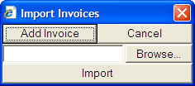Most of the time, you’ll do this once a month, and never have to import more than one invoice (the most recent one) at a time. But, if you need to, you can click “Add Invoice” to import multiple invoices at the same time:

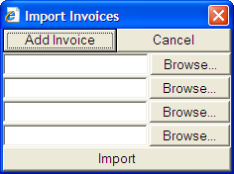In fact, you can do as many as you want. Use the “Browse…” buttons to select the invoice files that you want to import, and then click “Import”. Using the UkrMTS importer (which you are), the program window will then disappear until it’s finished running. You can now go off and do something else for a few minutes while it runs. The program will periodically produce pop-up boxes to tell you how close it is to finishing each invoice, and display the total time required to process each invoice. Once you’ve imported an invoice, you never have to do it again, unless you do something silly and accidentally overwrite or delete the database file for that month.

Now let’s make a basic phone report; click “Set Up Report”, and you will see the following dialog box:

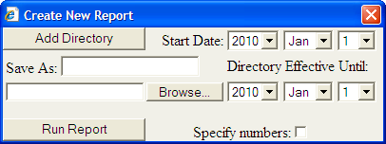Click the “Browse…” button and find the directory file that you made. Then use the drop-down boxes to select the starting and ending dates (inclusive) for the report. Then click “Run Report”; the program will generate a report based on the numbers found in the directory file, and save it as “PhRepYear_Month_Day”, where “Year_Month_Day” is the numerical representation of the current date, in the “Phone Records” folder (which, just in case you deleted it, will be created automatically). If you want it to be saved as something else (particularly if you’re going to do multiple different reports in one day), you can type your own file name in the “Save As” box, and that will be used instead. The program will periodically produce pop-up boxes to inform you of its progress, but you can mostly ignore that until it says “DONE!”

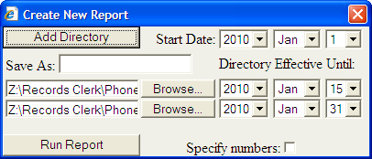You can select the starting and ending dates for a report to be anywhere in the range of time for which you have data; if you select the start and end of one transfer, then you will probably only need one directory file (unless there was mini-transfer somewhere in there). But in any other case, such as doing reports based on month, or whenever the time period might include a transfer date (or multiple transfer dates), you’ll need more than one directory file. So, click “Add Directory”:

As with importing invoices, you can add as many directories as you want (until the dialog box gets bigger than the screen).

Each directory is accompanied by its own set of drop-down boxes to select the last date on which it is effective; the next one in the list will take effect on the next following day. So, consider this example, where we’re running a report for the month of January, and we have a transfer on the 16th; the report starts on January 1st, and the 1st directory file is valid through the 15th. The second directory file will then take effect on the next day, the 16th, and be valid through the 31st, where the report ends.

Sometimes, the phone company may mess up, and one of the phones you want to track may not be included in the invoice (and therefore may be missing from the database) for a certain month. In this case, the program automatically scavenges as much data as possible for that phone number from the calls to and from other phones included in the invoice; however, a message will be displayed in the main screen to indicate that that phone was missing from the original invoice for a certain time period.

Now you may be wondering about the “Specify numbers” checkbox. Click on it, and an additional text field will appear.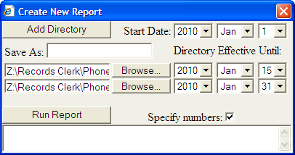 This lets you type a comma-separated list of phone numbers for which to generate a report. This overrides the directory files; the directories will still be used to replace phone numbers with names and determine highlighting, but report pages will only be produced for the numbers listed in the box. This not only allows you to generate small reports for individual companionships, districts, etc., but also allows you to generate reports for foreign phone numbers, showing all of the calls that have been made between them and the mission.

So far, all reports will be generated with certain default settings for highlighting, permitted calling times, and what kinds of calls to record or ignore. To make different kinds of reports, click “Change Settings”:

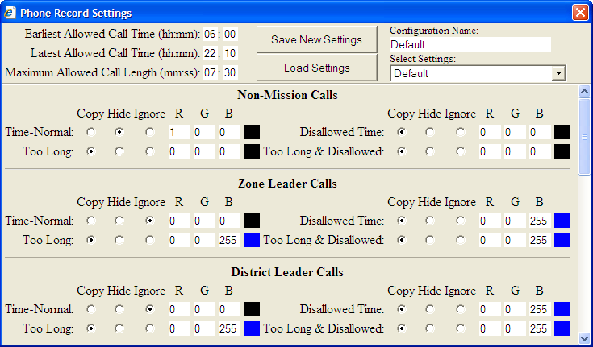

Here, you can change the earliest and latest permissible call times, the longest permissible call length, which of 33 different call types will be included in the report, and how they will be color coded. Call types are based on 8 different possible calling-tree relationships, multiplied by 4 variations of time-status (equals 32), plus the default highlighting for specially tracked numbers. Each call type can be either “Copied” (making it visible in the report), “Hidden” (Including in the Excel file, but as a hidden row), or “Ignored” (leaving it out of the report altogether). Copied or Hidden call types also receive their own color-coding, which you set by typing in the values for the Red, Green, and Blue color channels; you’ll get a preview of what the final color looks like as you play around:

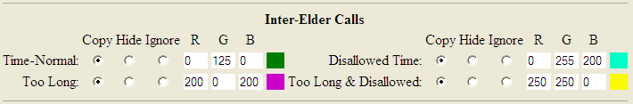

This is additionally useful for figuring out what to type into the directory for special tracking colors. Note that the “Special Tracking” option in the settings controls the default highlighting, which is used if no specific color is specified for that phone number in the directory file.

When you first open this dialog box, default settings will be loaded. The “Select Settings” dialog box allows to choose from different previously-saved sets of settings, which you can apply by selecting an option and clicking “Load Settings”. Any changes you make will immediately take effect, and you will see your changes remain if you close and re-open the dialog box. If you screw up, however, these changes are not permanent- they will be lost if you close and re-open the whole program, or you can get back to the original settings by clicking “Load Settings” again. To make your changes permanent, type a new name in the “Configuration Name” box, and click “Save New Settings”. A new option will then be added to the drop-down box for your saved settings. Be careful, though- if you don’t type a new name, old configurations will be overwritten!

And that’s about it, so if you have any questions, e-mail chronosurfer@gmail.com.